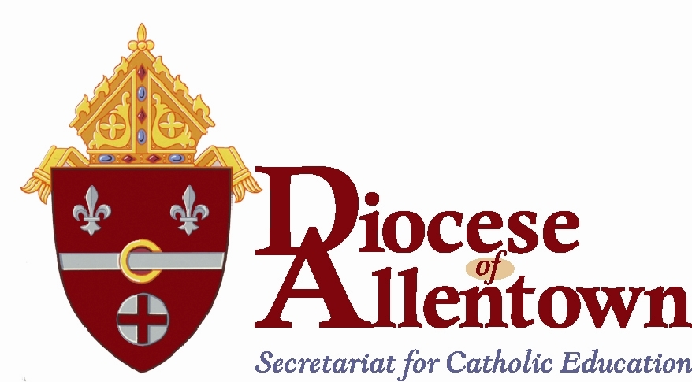

RECORD KEEPING REQUIREMENTS

- Teacher files
If a teacher transfers to another parish elementary school, within the Diocese, copies of clearances and applications are sent to the new parish elementary school. If a teacher transfers to a school outside the Diocese, the teacher’s file is kept at the local school.

- Student Records
Roll Slips are kept in the school permanently
Permanent Record Cards follow students going to Catholic Schools; cards of students going to public school are kept in storage (copies may be sent to
public school).
Health Records are to follow the student to their next school
Absentee Notes should be held for the current school year
ILA and Math Portfolios should follow the student to their next school
Act 90/195 keep for seven years
Standardized Tests Record Card keep permanently
Minutes of Faculty Meetings keep for one year after the term of the
former administrator
Middle State Self-Study and Report of Visiting Team Keep permanently
Reports from the Office of Catholic Education Visitation Keep five years
Building and Asbestos Report Permanently
Lead Report Permanently

SCHOOL CONSOLIDATIONS

When a school closure takes place, the Permanent Record Cards/Standardized Test Card, Roll Slips and the Medical Records of those students who are enrolled are forwarded to the NEW school.

All inactive Permanent Record Cards and Roll Slips are to be kept at the New School in a file cabinet

The Permanent Record Cards/Standardized Test Cards and the roll slips are to be preserved permanently.

Any other information that is in the students’ files should be shredded.

