Religion – Kindergarten Curriculum
The fourfold framework of the Religion Curriculum K-8 involves Message, Worship, Community and Service. Message includes beliefs and moral practices. Worship includes prayer, sacraments and Eucharist. Community includes the local parish and the universal Church. Service includes the concern expressed and practiced on behalf of the others. The Catechism of the Catholic Church (USCC, 1994) is the source of the doctrinal elements to be developed and is a primary resource for catechesis.

The following unit ideas supplement and expand the formal curriculum.

TEACHING-LEARNING CYCLES

I. Self-Awareness and Appreciation

VIII. The Celebration of Jesus
II. People in Our World

VII. Mary, Our Heavenly Mother
III. Our World of Nature

VI. The Life of Jesus
IV. Celebrations and Prayer

VI. The Life of Jesus
IV. Celebrations and Prayer
V. God’s Greatest Gift - Jesus

V. God’s Greatest Gift - Jesus

Eight major themes seem to recur in published early childhood materials for catechesis:

- self-awareness and appreciation
- people in our world
- the world of nature
- celebrations and special days
- God’s greatest gift – Jesus
- The life of Jesus
- Mary, Our Heavenly Mother
- The celebration of Jesus
Kindergarten children are basically simple and honest in their day-to-day living and are becoming more aware of the people and objects around them. Children at this age are very impressionable and accept literally and with great trust all that the adult world has to offer.

Actions, movement, and a carefree spirit describe their inclinations. Most children are not inhibited and enjoy creativity in movement, written expression, and language. Aware of these characteristics, the religious program should be based upon concrete experiences rather than abstract.

The whole child should be involved through movement, dramatization, role-playing, art, and music which allow the child to relate to God in his own language rather than in a formal manner. This relationship with God, represents continuous development, beginning with innate awareness of God and leading to the reality of God’s love for the child and his freedom to love God in return.

The atmosphere of the Catholic school and the religious education program are the reasons why parents choose to send their children to a Catholic kindergarten, and as teachers, our role is to support families, who are the primary educators of the faith.

Parents have the first responsibility for the education of their children. Parents should initiate their children at an early age into the mysteries of the faith of which they are the “first Heralds” for their children. They should associate them from their tenderest years with the life of the Church. (Catechism of the Catholic Church, #2223 and 2225)

Education in the faith by the parents should begin in the child’s earliest years. This already happens when family members help one another to grow in faith by the witness of a Christian life in keeping with the Gospel. Family catechesis precedes, accompanies, and enriches other forms of instruction in the faith. Parents have the mission of teaching their children to pray and to discover their vocation as children of God. The parish is the Eucharistic community and the heart of the liturgical life of Christian families; it is a privileged place for the catechesis of children and parents. (Catechism of the Catholic Church, #2226)

“The primary responsibility for the growth and education of young children rests with their parents and families, for the family is . . . the principal school of the social virtues which are necessary to enter society.” (Second Vatican Council Declaration on Christian Education, #7)

Objectives
These religion guidelines may be used, in conjunction with any basic text, for enrichment.

- To help the children express their enjoyment of God’s gifts through prayer and gesture.

- To enable the children to be aware of and concerned for the needs of others by responding kindly to others at home, school, church, and on the playground.

- To begin sharing with children a common interest in promoting respect for human life.

- To enable the children to demonstrate a knowledge about the events in the life of Jesus by retelling these events through activities.

- To help the children to respond in love and appreciation of God’s goodness in creating them and the world about us.

- To provide the children with various experiences relating to the liturgical year: Advent, Christmas, Epiphany, Lent, Easter.

I. Self-Awareness and Appreciation
Children are becoming more aware of different people in their daily contacts. They are realizing the importance of each individual simply because they are special in God’s plan. The children recognize that they are learning more about themselves and others by spreading joy and happiness to all of God’s family. Children should experience the joy of being alive and reflect on the happiness of respecting life.

Concepts


- A child is special.
- A child is unique and lovable.
- A child has personal worth.
- A child has feelings.
- A child can love others.
- A child can make choices.
- A child needs family love and unity.
- A child needs to belong.
- A child belongs to many groups.
- A child should enjoy and respect life.
Specific Objectives

The learner will:

- realize how special everyone is in the classroom.
- be able to see life as a precious gift from God.
- show recognition of differences and similarities observed in people.
- be able to show recognition of individuality and personal worth by verbalizing the discovery of the various talents given by God.

- identify the people who love and help him through an expression of feelings.

Learning Experiences
- Self Portraits – Children can use a mirror in a box (real or spread aluminum foil on oak-tag) to see themselves and others as special. Faces can be drawn on paper with crayons to realize they are all different, yet have much in common.

- Life size figures – Teacher traces child’s body on large sheets of paper. Children fill in simple features and clothes.

- Paper plate faces – Using a paper plate, children add features with yarn, construction paper, crayons, etc. Face trimmings help to express feelings and moods. Make up stories about why they might be looking that way.

- Display pictures of people. Discuss the sacredness of life and respect for all human life.

- Paper dolls – Have each child draw and cut out a paper doll. Teacher can connect dolls together and display them near religion center.

- A Booklet About Me – Children assemble a book including pictures of themselves, family, friends, favorite color, favorite food, and favorite things God has made and provided for them.

- Finger puppets – Have children make puppets displaying different emotions (happy, sad, angry, tired, etc.) Meet with the class to discuss how the children feel in different situations.

- Collage – Using magazines, have the child find pictures of things she likes, or various pictures showing joy, life, growth, or relationships.

- Open – ended discussions – Using various pictures that show different situations and emotions, have the children draw conclusions.

- Fingerprint – Each child makes his own fingerprint or hand-print using a stamp-pad or finger paint. Then have children compare these to show how each one is different. No two are alike.

- Class Kindness Box – Children share others acts of kindness with teacher. Names are put in the box and rewarded at the end of the month.

- Play games in which teams are chosen. Plan so all children have the experience of being chosen early.

- Use special name tags; play or sing name games; always use each child’s name with love and reverence.

- Read books, discuss the importance and naturalness of feelings as gifts God gave us. Allow children to role-play situations involving various feelings.

Learning Experiences
I Am Special Prayer

God gave me
Two eyes to see with
A nose to smell with
Ears to hear with
A mouth to speak with
Two hands to work with
Feet to tiptoe with
I’m a lucky child, aren’t you?

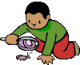

ABC’s Don’t Grow on Trees

ABC’s don’t grow on trees.
That’s not the way God made them.

The shining sun won’t ever run.
That’s not the way God made it.

A little bird won’t speak a word.
That’s not the way God made it.

The little dove will never love.
That’s not the way God made it.

But I can grow and speak and run
and think and love!

I Am Special
(Sung to the tune: Mary Had A Little Lamb)

I am special yes I am,
Yes I am, yes I am.
I am special yes I am,
Jesus loves me.

- People in Our World

The beginning of a religious approach to life begins when a child understands that love and acceptance starts at home and in the family. A child will begin to understand that God’s love is much like the love of parents, grandparents, brothers, and sisters. It is like the love she experiences in whatever family setting is hers, whether it be the traditional, the extended family, or the single-parent family.

Concepts

- Children tell about their home and family by sharing ideas.
- Family is important to them because the family is where they are loved.
- Our own home is special to us.
- Parents love their children.
- God loves all of us.
- God is our Father, and that makes us all members of the Family of God.
- God is good and God loves us so much that He gives us special people: parents, grandparents, etc.

- God loves children just as their parents do.
- God’s love is much like our parents’ love.
- God loved us even before we were born.
- God is our greatest friend.
- Baptism makes us members of God’s family and His special friend.

Specific Objectives

The learner will:
- be able to discuss and share appropriate home and family events.
- realize the uniqueness of each individual member of a family.
- recognize that each individual is special in God’s family.
- realize that the family unit is where love is found.
- experience the home as being special.
- realize that parents love their children.
- be aware that God loves all of us.
- realize that God is a loving Father who is always present.
- associate God’s love with their parents’ love.
- realize that parents are special.
- begin to recognize that God loved all of us even before we were born.
- realize that God is a great friend.
- associate the term ”family” in relationship to God’s family through Baptism.
- realize that life experiences of other people will convey the truth of which the Bible speaks.

Learning Experiences

- Develop a family theme – Make a family mobile using a coat hanger and pictures of the child’s family. Draw a family mural. Role play a family scene. Hold a discussion about family members and friends. Use children’s literature, poems, and songs as the basis for the discussion.

- I am special – Children trace over these letters which are on a circle. Attach yarn and place over the head as a necklace.

- Friendship Chain – Each child decorates a paper strip and joins it together to show unity.

- Baptismal Service – Celebrate the Baptism date as you would the birthday. Use a small Baptismal stole with the symbol and a candle. The stole is the sign of purity and the candle is the sign of the “Light of the World.” Check the school file for the baptismal dates of the children.
The children may bring in Baptismal pictures to be shared with the class. Discuss and identify the godparents and the selection of the child’s name.

- A suggested prayer service –

Theme: Thank You, Lord
Format: Song – “Thank you, God” from the record, Hi, God

Use simple prayers as petitions with a response of “Thank you, Lord.” Children can bring to the altar pictures of things for which they are thankful. Have a closing song or finger play.
I’m Glad

I’m glad for puppies;
They have such fun!

I’m glad for kittens:
See how they run!

I’m glad for bunnies,
Soft and so small.

I’m glad for elephants,
Wrinkly and tall.

I’m glad for fish
Swimming in the deep sea.

I’m glad for birds
Flying high as can be.

I’m glad for lions
And tigers that roar.

I’m glad for my parents
And, oh, so much more!

III. Our World of Nature

Little children are curious and they need to view the beauty of the world God created. They have the ability to admire and to affirm the wonderful world we live in. God’s gifts are the greatest and God gives them to us because God loves and respects us.

Concepts

- Everywhere we look we see many gifts given to us by God.
- God’s love is shown through God’s many gifts of sharing.
- God is the creator of all things.
- Harmony and order in the world of nature is the end result of God’s great plan.
- God gave us a body and a soul; God gave us life.
- God has given us our sense of smell, touch, taste, sight, and hearing.

Specific Objectives

The learner will:

- appreciate creation as an act of God’s love for us and that God is our Creator.
- realize that a gift is a sign of love.
- be aware that God’s gifts are the greatest of all.
- realize that God’s gifts are everywhere.
- recognize and care for all God’s gifts.
- realize that animals are a gift from God and that they give us food, warmth, and affection.
- realize that God gives us water to help us stay alive, to have fun, and to be closer to Him.
- realize that God has given us light to keep us warm, to have fun, and to help others.
- realize that God has given us the wind and air to breathe, to cool us, and to remind us of Him.
- become aware that the stars, the moon, the sun, the trees, flowers, and other things that grow are gifts from God to make us happy.

- be able to express feelings of joy in sensory experiences of touching, feeling, smelling, hearing, and seeing through various activities.

- show respect for the bodies God gives us to help us do things for ourselves and others.
- realize that God gave us a body and a soul.

- become aware that every day we can discover things about God by looking closely at the world.

- be able to identify and list the gifts God has given us in the world of creation.
- identify the terms “create” and “creator.”
- realize that God can make anything.
- explore natural signs as a basis for liturgical symbols, e.g., light, water, oil, bread, fire, etc.
Learning Experiences

- God made everything – Provide each child with a flower that has seven petals. On each petal the child draws what God made each day of creation. This may be followed by memorizing the following poem:

A Child’s Thank You

Thank you for the world so sweet.
Thank you for the food we eat.
Thank you for the birds that sing.
Thank you, God, for everything.

- Banners – Children make individual banners from paper, felt, or cloth scraps. One procedure is to attach straws to top and bottom of 9X12 sheets of paper. Run yarn through the straw to hang the banner. Suggested themes: joy, sorrow, thanks, family, creation, life, helping, caring.

- God made the seasons – Keep a branch in the religion center and show change of seasons by having the children attach fall leaves, snowflakes, flowers, etc. This branch may be placed in a coffee can or vase filled with sand or plaster of Paris.

- Creation play – Have children make pictures of the things God made during the six days of creation – for example: water, sky, land, vegetation, sun, moon, stars, creatures, fish, birds, land animals, man. Using a children’s Bible, cut out the story of creation. Puppets may be made using tongue depressors with pictures attached.

- Dramatize – Have children imagine they are flowers, animals, or birds, etc. Tell why God made them and how they are important.

- Grow Plants – Have the children plant seeds in the classroom.

- Nature table – Take the children for a walk through the yard, park, or the woods for the purpose of seeing God’s creation and talking about the things God made. Collect a few articles to display.

- Creation booklet – Make a booklet based on the story of creation. Illustrate it with pictures from magazines or original children’s pictures.

- Draw pictures of the sun and explain how it helps us by giving light and heat, dries clothes, makes plants grow, and makes us strong and healthy.

- Draw pictures of various animals God made. Make a large classroom collage in the form of an animal parade.

- Cut pictures of fruit, vegetables, animals, etc. from magazines and make a booklet.

- Help children make up riddles about various animals, fruits, the sun, the moon, stars, and other elements of creation.

- Read the following prayer to the children and discuss the wonders of nature.

The World Around Me Prayer
Thank you God, for making
The earth, the sky, the sea,
For making family, friends and animals
And thanks for making ME.
AMEN

- Provide activities that would lead to wholesome experiments with the senses, for example: tasting party, recognizing different sounds, being able to detect certain odors.

- Use large pictures and photographs of nature’s beauty for reflective and prayerful moments.

IV. Celebrations and Prayer
A child is special in his family and in God’s family. Since we are one in God’s family, the Church, we all share in God’s gifts of creation. We express our love for God through dialogue called prayer and through celebration. We tell God about our needs and He teaches us about His love for us. Prayer is a source of spiritual growth, God’s forgiveness, faith-building, and God’s guidance.” . . . whatever you ask in prayer, believe that you have received it, and it will be yours.”
Mark 11:24

Concepts

- God is our Father.
- God made all things and God made us.
- Prayer is talking to God with love.
- God teaches us about His love for us.
- People always have felt the need to be closer to God, and prayer fills this special need.
- People pray to praise God, to express love of God, to thank God, to express sorrow for wrong doings, to help others, and for personal need.

- Prayer is a conversation between God and the person.
- The perfect prayer is the Lord’s Prayer.
- Praying can be done anytime.
- Prayers are always answered, but the answer may not be what we expected.
- Great men and women of God show the power of true prayer.

Specific Objectives

The learner will:

- realize God is our heavenly Father.
- realize we are all members in God’s family.
- be able to express gratitude to God for all His gifts.
- identify the term “prayer” as talking to God with love.
- be able to express love for God in response to daily experiences, in friendship with others, and have a special closeness with God.

- realize that we tell God about our needs and He teaches us about His Love.
- be aware of the need to be close to God; prayer fills this special need.
- realize the need to pray for help, forgiveness, thanksgiving, and knowledge of God’s presence.

- be aware that prayer is special to God and it involves thinking, feeling, and willingness.
- recognize the kinds of prayer: Thanksgiving, Forgiveness, Praise and Adoration, Petition or Intercession, and Guidance.

- realize that the “Our Father” is the perfect prayer.
- recall that prayers can be said anytime.
- realize that God does answer our prayers, but the answer may not be what we expected.

Learning Experiences
- Plan simple para-liturgical celebrations in the classroom.
- Direct the children to turn their work and play into prayer.
- Make little intentions during the day: for the sick, when you hear a fire-truck siren, ambulance, etc
- Show the children how to make a minute meditation about God.
- Remember to say “Thank You” after you receive something from God.
- Learn the “Sign of the Cross”, the “Our Father”, and the “Hail Mary” through the use of song and pantomime.

- Draw a picture of yourself while saying a prayer to God.
- Experience different prayer techniques.
- Spontaneous prayer – Use a coffee can, cross, bottle, ball or other objects decorated with pictures. Children pass it around in “prayer circle” and say their own spontaneous prayers such as “Thank you for “ or a petition prayer related to the pictures.

- Provide a Prayer Table and decorate for the Liturgical Season. Example: colored cloth, candle, Bible, etc.

- Sing an “Alleluia” as part of morning prayer. Begin at the start of the school year and stop the day before Ash Wednesday. Resume on Easter Sunday. (The church does not use the “Alleluia” during Lent.)

V. God’s Greatest Gift – Jesus
A natural symbol speaks for itself. The importance of the natural symbols is that they link a child’s experience within to what is outside. Children, through these symbols, can better know reality. God uses natural symbols such as water, fire, wheat, to convey messages to His people. In this way, natural symbols become religious symbols. The sign of giving is a gift, and the greatest gift is Jesus.

Concepts

- God sent Jesus to us as a very special gift of His love.
- Jesus was sent to show us how to love one another.
- Jesus first came to us as a baby in Bethlehem. (Christmas Story)
- Advent is the time to get ready to celebrate Jesus’ birthday.
- We collect our gifts of love during Advent to give to Jesus as our birthday presents.
- We learn about an Advent calendar.
- The Advent wreath is a sign that Jesus is coming.
- Many, many years ago, people also waited for Jesus to come on His first birthday. They prepared their gifts of love.

- The Bible is God’s storybook where we find out about God’s gifts and His great love for us.
- We learn about the Jesse Tree and some of the people who waited for Jesus: Adam and Eve, Noah, Abraham, Isaac, Moses, Wise Men, Shepherds, Mary, and Joseph.

- Christmas is the birthday of Jesus. The birthday of Jesus is a time for a celebration because He is our God.

- Jesus is the light of the World.
Specific Objectives

The learner will:

- become acquainted with the signs of Christmas, e.g.: Advent wreath, Christmas tree, crèche, gifts, and Jesse Tree.

- realize that Christmas is a time of giving because God gave the best present which is Jesus.
- discuss the events and characters pertaining to Christmas.
- be able to demonstrate through daily actions the anticipation of the birthday of Jesus.
- be able to tell ways in which he can help other people in God’s family.

Learning Experiences

- Advent wreath – Have each child trace her hand on green construction paper and cut out. Assemble into a wreath shape on bulletin board. On each Monday of Advent “light” a candle with a cut out red flame.

- Advent Calendar – Give each child a Christmas tree with ornaments outlined on it with the dates of Advent. The children color in the days up to Christmas, one day at a time as they wait. They take the tree picture home before Christmas vacation. Christmas Eve they add the Christ Child at the base of the tree. Another version is to prepare a calendar and have certain virtues or kind deeds each day.

- Jesse Tree – Decorate a tree with Jesse Tree symbols as the children learn of others who waited for Jesus: Adam and Eve – an apple; Noah – a rainbow; Abraham – a ram or sticks; Mary – a heart; Joseph – a ruler; Moses – a burning bush; David – a crown; Isaac – a ram or sticks; Joseph and his brothers – a striped coat; Solomon – a temple. Each day tell the children a different story and hang a symbol on the tree. Tell the children that the tree is named after one of the relatives of Jesus from whom he descended.

- Birthday Celebration for Jesus – Display the Nativity scene and have children dramatize the Christmas story.

  - Display a box symbolizing a manger. As the children complete good deeds, they can add a piece of straw or a strip of paper to anticipate Jesus’ birth.

  - Make a spiritual crib with the children. Discuss each day preceding Christmas what will please Baby Jesus most that day. Decide what to do and how to do it.

  - Children can ask their parents to contribute an article of clothing, food, or toys to needy families or underprivileged children.

- Children make small gifts or bake cookies to give to school personnel as a way of sharing.

- Christmas Story Art – Make a Christmas mobile of the figures in the Christmas story.

- Puppets – Make hand puppets using cloth for bodies and Styrofoam balls for heads. Act out the Christmas story. A stage can be fashioned from a large box behind which the puppeteers can stand and manipulate the puppets.

- Christmas Card Panel – Children collect Christmas cards with pictures of the Holy Family, etc. Give each child a strip of brightly colored paper, 4” X 18”. Children paste the pictures on this paper and punch a hole at the top for a yarn holder. Pictures can then be hung from the lights or a hanger for the feast of the Holy Family.

VI. The Life of Jesus
Jesus came to be our leader. His job was to spread the Good News of God. Jesus used parables and miracles to teach us how to live a good life. His life was an example for us to follow. Jesus truly showed that He was God through His suffering, death, and resurrection.

It is important that each teacher place emphasis on the message conveyed by these stories, rather than on the details. Stress should be put on the virtues taught by Jesus.

Concepts

- Jesus is the greatest teacher.
- Jesus shows us how to love one another through His example.
- Jesus has special powers to do miracles.
- Jesus is God!
- Jesus loves children.
Cure of the official’s son John 4: 46-54
Cure of Jairus’ daughter Matt 9: 18-26
Blessing of the children Mark 10: 13-16

- Jesus loves sick people.
Cure of the paralytic Mark 2: 1-12
Cure of the blind man Luke 18: 35-43
Cure of the ten lepers Luke 17: 11-19

- Jesus loves sad people.
The calling of Matthew Mark 2: 13-17
Raising of Lazarus John 11: 1-44
Wedding Feast of Cana John 2: 1-12
Story of Zachaeus Luke 19: 1-6

- Jesus loves frightened people.
Calming of the storm Mark 4: 35-41
Jesus walks on water Matt 14: 22-33

- Jesus loves hungry people.
Multiplication of loaves and fish Matt 14: 13-21
Catch of fish Luke 5: 1-11

- Jesus even loves people who turn away from the Father.
Prodigal Son Luke 15: 11-32
Mean Servant Matt 18: 21-35

- Jesus loves us so much that He gave His life for us.
- Jesus died on the cross for us.
- During Lent we remember Jesus’ passion and death.
- During Lent we do special things to show Jesus our love for Him.
- On Easter we celebrate Jesus’ rising from the dead.
- Jesus brought us new life and hope.
Specific Objectives

The learner will:

- become acquainted with the events in Jesus’ life.
- realize that each member of God’s family shares in the work of Jesus by spreading love and happiness.

- recall stories and events that show the power and the awe of Jesus.
- realize the need for forgiveness.
- relate ways in which he could help spread the work of Jesus.
- recognize the greatest proof of Jesus’ love was His life, death, and resurrection.
- become familiar with the signs of new life.
- be able to express love and gratitude for the presence of the risen Jesus through prayer and worship.

- be able to retell in word and action the parables and miracles relating to the love of Jesus.
Learning Experiences

- Dramatize the parables of Jesus with children acting out the parts or through the use of paper bag or stick puppets.

- Plant seeds to have ready by Easter.

- Make an “Alleluia” poster, banner or have children color and decorate the word “Alleluia.” Hide this banner or picture on Ash Wednesday to emphasize that this is the time to think about Jesus’ life and death and of His great love for us.

- Make cross mosaics with scrap paper or cloth.

- Read or explain the Stations of the Cross in a very simplified manner, and ask the children to reflect on how much Jesus loves us.

- Provide mission or Lenten boxes to collect coins for the needy.

- Lenten Calendar – Plan one special act or prayer for each day of Lent for all children to do at home or at school.

- Lenten Pretzels – Use pretzel recipe in appendix. Make pretzels with children after discussing the following poem, “Lent.”

LENT
During Lent long, long ago
In countries far away,
The people made a bread that would
Remind them they should pray.

Some water, salt, and flour
Were mixed with greatest care,
Then the dough was shaped like arms
That cross the heart in prayer.

We, too, can have this twisted bread
On any Lenten day.
The little pretzel still is here
Reminding us to pray.
SEE JESUS
See the boy Jesus, little child like me.
See the boy Jesus, climbing up a tree.
See the boy Jesus, see Him running there.
See the boy Jesus, on His knee in prayer.

See the man Jesus, walking by the sea.
See the man Jesus, children on His knee.
See the man Jesus, loving everyone.
See the man Jesus, asking me to come.

- After reading the miracle of the loaves and fishes, the children can trace a fish. The children then cut the fish and place them in a basket pinned to the bulletin board.

- Make a Holy Week book and/or re-enact a simple Seder meal.

- Crayon resist cross – Blocks can be crayoned on cross pattern leaving white borders between blocks. Black paint is washed over the cross to give a stained glass effect.

- Easter egg tree – Take a small branch and insert it into a paper cup or a small juice can containing plaster of Paris. Have the children design small colored eggs and attach to branches. These can be used as a motivation for prayer, etc.

- New Life – Use felt to make a colorful Easter egg or dye hard-boiled eggs.
    - Hatch real butterflies from caterpillars. Kits can be obtained from educational science companies. Children watch each stage. Release new butterflies in special ceremony. Relate the life cycle changes to changes in the life of Jesus.

    - Make a mobile using flowers, butterflies, and birds; or make a collage.

    - Use the Easter bunny as a symbol of new life.

VII. Mary, Our Heavenly Mother
Mary was chosen to be Jesus’ mother from the very beginning of time. She exemplified a life of total commitment to God through her every day, ordinary routine and lifestyle. She teaches us simplicity of life and unquestioning obedience to God’s will. We pray to her and ask her help in keeping us close to her son, Jesus.

Concepts

- Mary came from the family of Joachim and Ann.
- Mary always showed her love for God. (Immaculate Conception)
- We learn how Mary was chosen to be Jesus’ mother. (Annunciation)
- We learn of Mary’s love for her cousin Elizabeth. (Visitation)
- We learn of Mary’s marriage to Joseph.
- It was not easy to be Jesus’ mother. There were many hard times and sad times.
- Jesus gave Mary to us as our heavenly mother.
- Mary lives in heaven now with Jesus. (Assumption)
- She is the Queen of heaven and earth. (Coronation)
- Sometimes Mary has come back to earth to visit special people and to tell them to keep loving God. (Fatima and Lourdes)

- A beautiful prayer of Mary is the rosary.

Learning Experiences

- Draw pictures that depict some scenes from Mary’s life.

- Block off a stained glass window shape and color the areas in contrasting colors. The child then cuts out a picture of Mary (Christmas cards are a good source) and pastes it in center of window design. Outline in black crayon.

- Children design paper or tissue flowers. Use the flowers to outline or decorate a bulletin board for Mary.
30
- Mary Altar – Children cover a small table with cloth. Place a statue of Mary on it with several candles and bouquets of flowers.

- Children can say a decade of the rosary each day during the months of October and May.

- Make a paper chain rosary using different colors for each decade. Use yarn to separate the decades.

- Children collect pictures of people (all ages) and form a collage on paper or bulletin board. Place Mary’s picture in the center. She is the heavenly mother of all people.

- Give the children a picture of Mary surrounded by drawings of flowers. Each day after the child has said a prayer to Mary or performed a small task of obedience, she may color a flower. By the end of May or October the picture should be completed.

VIII. The Celebration of Jesus – The Liturgy
As members of a special family we are called forth to share our prayers and love in God’s house, the church. Through our Baptism, we share in the life and work of Jesus. Jesus was aware of our needs so He gave us the gift of Himself through the Mass. The Mass (Liturgy) is a gift-giving experience and a meal celebration where we share in the joy of being God’s children.

Concepts

- We celebrate as the people of God.
- One of the best ways to show our love to God is to come together as a family to worship and honor God at Liturgy.

- Liturgy is a celebration.
- Liturgy of the Eucharist is a meal we share together.
- Liturgy is an act of thanksgiving.
- At Liturgy we give ourselves to God.
- We participate in the Liturgy through praying and singing.
- People from the parish are chosen to be special helpers.
- A priest leads the celebration.
- Holy Communion is Jesus coming into our hearts.
- Jesus will come to me in a special way when I am prepared for my First Holy Communion.
- The Liturgy brings us peace and joy.
- The Liturgy brings the family of God closer together.
- The church is the special place where we celebrate Liturgy.
- The church is God’s special home.
- My good behavior at Liturgy is a sign of my love for God.

Specific Objectives
The learner will:
- become familiar with participation within the Liturgy (Mass).
- be able to express love for God through gestures and simple prayers.
- recognize the joy of life by being a cheerful giver.
- be able to express and share experiences at church.
- experience short visits to church.
- be able to carry the message of the Eucharist into daily life.

Learning Experiences
- Liturgy – A goal for the school year can be a liturgical celebration for the class. It should be prefaced with preparation including a visit to the church and simple explanation of the parts of the Mass, priests, vestments, chalice, ciborium, and unconsecrated hosts.

- Children design and make a holy water container.
- Children draw or find in magazines pictures that depict love and display them on a large heart poster.

- Banners – Can be designed from burlap and felt scraps showing the themes.
- Prepare with children a creative mural on the Mass, Baptism, or other celebrations. Use different media.

- One with Jesus – Collect various pictures of all different people. Make a collage and cut a large chalice from this collection of pictures.

- Happiness with Jesus – Children make a sponge print or a potato print background. Place the self-portraits on the painted backgrounds. One child may paint a picture of Jesus, ciborium, tabernacle.

- Role play the Last Supper.

ADDITIONAL LESSONS
Church Manners and a visit to church
The way we act or treat others shows either good manners or bad manners. How should we act in God’s house, the church? Since we all belong to God’s family, we should know the right way to act. Let’s discuss some simple rules:

- We should take our time and walk – not run or be in a hurry.
- We should try to be on time.
- We should always listen to the readings and what the priest is telling us.
- We should respect God’s house and take good care of the property.
- Remember we are to talk to God not our neighbor during the Liturgy.
- We should sing our praise to God and join in saying the Mass responses.
Let’s think about our own house. There are some things in our house that we can look for in God’s house, the church.

Open discussion:

Our House
- Chairs
- Table
- Lamps
- Flowers
- Pictures of family
- Crucifix
God’s House
- Benches or Pews
- Altar
- Candles
- Flowers
- Statues of God’s family
- Large crucifix

In church today, during the Mass, Jesus is made present to us when the priest blesses the bread and it becomes the Body of Jesus. When the priest blesses the wine, it becomes the Blood of Jesus.

Jesus is present in a special way in the tabernacle. The sanctuary light tells us that Jesus is there. Bells can be used to remind us of Jesus’ presence.

In God’s house, we should be quiet and talk to God in our hearts. We can give God thanks for all that has been given to us.

Rosary
The rosary is a beautiful prayer of Mary. Many years ago she came to earth to visit three children in Fatima and a little girl named Bernadette in Lourdes. On all of these visits, she always said the rosary with the children and asked them to continue to say it every day. She said that the prayers of the rosary are so powerful that if they were said every day by everyone, there would be peace in the world.
How wonderful it would be if all God’s children could live together in happiness. Let us try to say at least a part of the rosary each day. To the teacher: Most of the rosary can be taught to the children the second half of the year after they know some of the basic prayers. A decade a day could be recited by the class during the months of October and/or May.

Guardian Angels – October 2 (Celebrate the day by serving Angel Food Cake.)
God never wants us to be lonely or afraid, so each one of us has a special helper to watch over and to be with us at all times. This special helper is our Guardian Angel. Everyone in God’s family has a Guardian Angel. God knows all things and knows that we need extra help to spread happiness and love. That is why God gave each one of us our own special angel who would love us and help us to be good. Our Guardian Angels want all of us to be happy now and forever in heaven. They love us very much. Even though we cannot see or touch them, we know that they would help us if we just ask. We can show our Guardian Angels that we love them by being kind, sharing, and thoughtful. Every morning and every night we can ask our special angel for help by saying a little prayer.

Angel of God,
My Guardian dear,
To whom God’s love commits me here,
Ever this day be at my side
To light and guard, to rule and guide.
Amen.

St. Anne and St. Joachim – Jesus’ Grandparents

Grandparents are very special people. If I were to ask you why you think your grandparents are special, this is what you may say. . . “They let me sleep overnight; they tell me stories about the pictures of people on the wall; they take me places and we have fun together. Grandma lets me play with her jewelry and clothes; she bakes my favorite cookies, and she keeps special toys in a closet for play time. Grandpa plays with me; he listens to everything I say, and he tells stories or sings to me.”

Yes, grandparents are special because they love you in a very special way. They care about you, just like God cares about you.

In God’s family, Jesus had grandparents. His grandmother’s name was Ann. His grandfather’s name was Joachim. Jesus loved His grandparents very much. He would often visit them with Mary and Joseph. Jesus was very kind to them. He would ask if He could help them. Maybe He asked Grandma to sing a song or tell a story. Jesus was kind and thoughtful to them because they were older. He knew His grandparents loved God very much. They really loved God and tried to please Him through prayer and hard work.

Let’s ask Jesus to help us so we can be kind and thoughtful to our grandparents and to anyone who is older than us.

Thank you for my grandparents, Jesus.
You had nice grandparents, too, didn’t You?
Aren’t grandparents wonderful?
Thank you for my grandparents, Jesus.

To the Teacher: Celebrate Grandparents’ Day. Invite grandparents for Open House. Read a selection to the children from Grandmother God.

Advent

This time of the year the Church is getting ready to celebrate a very important day. It is something like getting ready for a party. Everyone in God’s family is waiting to celebrate Christmas, Jesus’ birthday. Think about your own birthday. Many times you say to Mom and Dad, “How many days until my birthday?” Also, you like to plan your birthday with some of your friends. You want your favorite cake and ice cream. Well, Christmas is the birthday of Jesus, and we have to get ready. The Church calls this time Advent because we are waiting to celebrate the true meaning of Christmas.

While we are waiting for the birthday of Jesus, we can make an Advent wreath. This Advent wreath reminds us of many things. The wreath is a circle. A circle has no beginning and no end. It is a sign of God’s love. It will last forever. Our Advent wreath will help us get ready to celebrate Jesus’ birth.

God loves us very much and wants us to share the greatest present, the gift of His son, Jesus. Since it is the birthday of Jesus, He should be the one receiving presents, but it seems we are the ones receiving them. Christmas is a time of giving. What can you give Jesus for His special day? Maybe you can say some prayers, help others, and try hard to be good listeners. We can be more helpful at home and in school. These would make nice birthday presents for Jesus.

God sent Jesus to be our teacher. Let us ask Jesus to help us prepare our hearts for His coming.
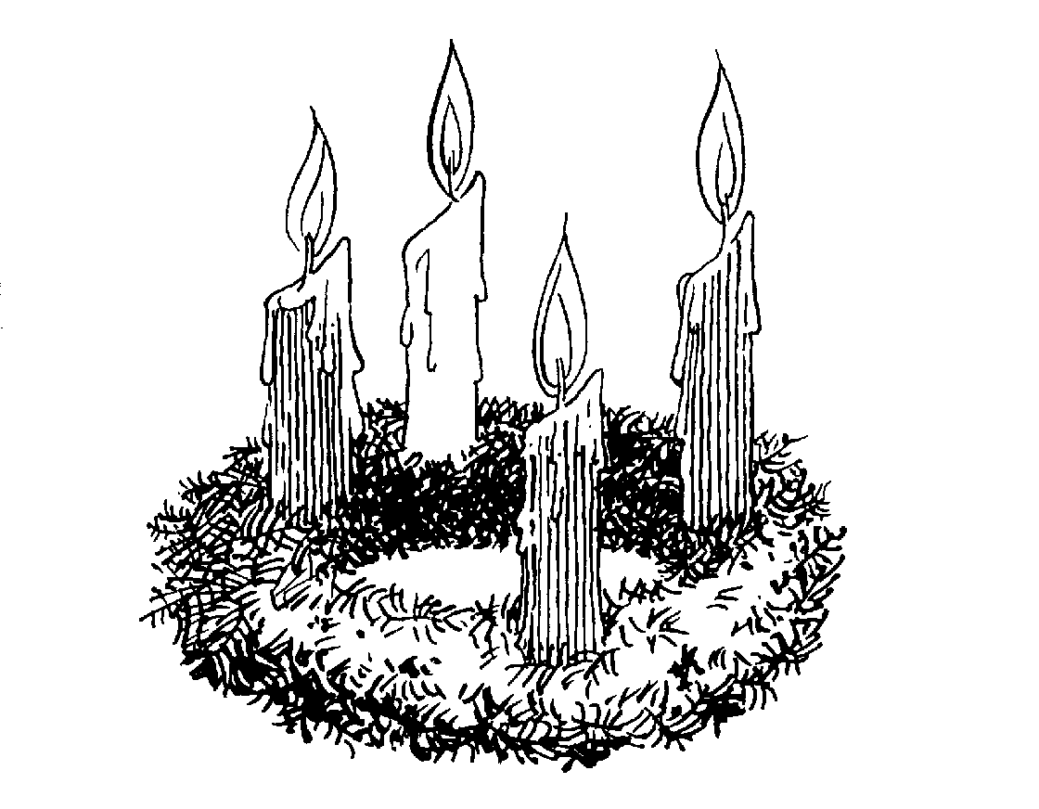
Dear Jesus, I love You.
Come and be born
In my heart. Amen.

To the teacher:
Advent Good Deed Chart – Children do a kind act; then they can color in the chart for that day.
Advent Wreath – Say special and spontaneous prayers at the beginning of each new week.
Advent Paper Chain – As each day goes by remove a paper link.

All Saints – November 1

If we are trying to do the things we are supposed to do because we love God, then we are saints!

The saints were once boys and girls like you. They loved God very much and tried to do many things to spread God’s love and happiness. They showed their love for God by doing everything for Him. They were God’s close and special friends. Some of these special friends were willing to suffer for God, even to die, as long as it pleased Him. Now they are always happy because they are with God our Father in heaven. These saints proved their love for God.

There are many saints in heaven. Heaven is God’s happy surprise and heaven is full of God’s friends. The feast of All Saints is the day on which the Church honors all the people who are sharing God’s home, heaven. These people earned their special surprise by doing what God our Father wanted them to do. They tried to be good and to spread God’s love to all. If we try to be good, then God looks to us as special little saints here on earth.

Today, let’s try to be kind to others. We, too, shall earn God’s happy surprise, heaven.

St. Nicholas – December 6

When Nicholas was a little boy, he was good and kind to God’s family, especially the poor children. As he grew older, he loved God more and more. Nicholas loved God so much that he became God’s special helper, a priest. Later he became a bishop. This means that he took care of many people and tried to help them love God so they could go to heaven.

Do you know that Nicholas never let anyone know what he was doing for the poor people? He would do this as a secret, just between God and Nicholas. He wouldn’t tell anyone that he made presents for the poor and that he took them to their houses. He did most of his kind deeds at night. Nicholas only wanted God to know, no one else.

When Nicholas died, the people missed him very much. They would remember him every year and they tried to be like him by spreading God’s happiness and love because he loved God and tried to please Him. The church called him St. Nicholas. Some people shortened his name by calling him St. Nick, and the little children knew him as Santa Claus.

Now children leave a stocking or a shoe out the night before St. Nick’s special day. The children hope that St. Nick will leave a treat for them. Let’s ask St. Nicholas if he would help us spread God’s love to all.

To the teacher:

Children can design their own stockings. Display them in the room.

Send a notice home to parents so they can prepare for this custom.

Aluminum Foil Shoe: Give children a piece of foil to mold around their shoe. Remove foil mold and put in a special place for St. Nick.

St. Nicholas Miter: Trace a bishop’s hat in red. Make a small yellow cross for center. Sprinkle glitter around top border. Glue cotton on bottom.

The Immaculate Conception – December 8

The Blessed Virgin Mary was such a special lady that from the very beginning of time when God decided to send Jesus to earth, He chose Mary to be different from all other women. God created Mary without sin. He blessed her in such a special way that from the time she was born until she went to heaven to live with God, she never did anything to make God unhappy. The Immaculate Conception is the day we celebrate Mary’s conception in her mother’s womb. Mary spent her whole life doing what God asked of her. Sometimes it was very hard to obey. Mary tried to please God at all times. Mary is the mother of God and our mother, too. With Mary, we want to be close to Jesus in our prayer, work, and our play. Like Mary, may we listen to God and do what he wants us to do.

Prayer and Response:

TEACHER: Mary, you are the Mother of Jesus and our mother, too.
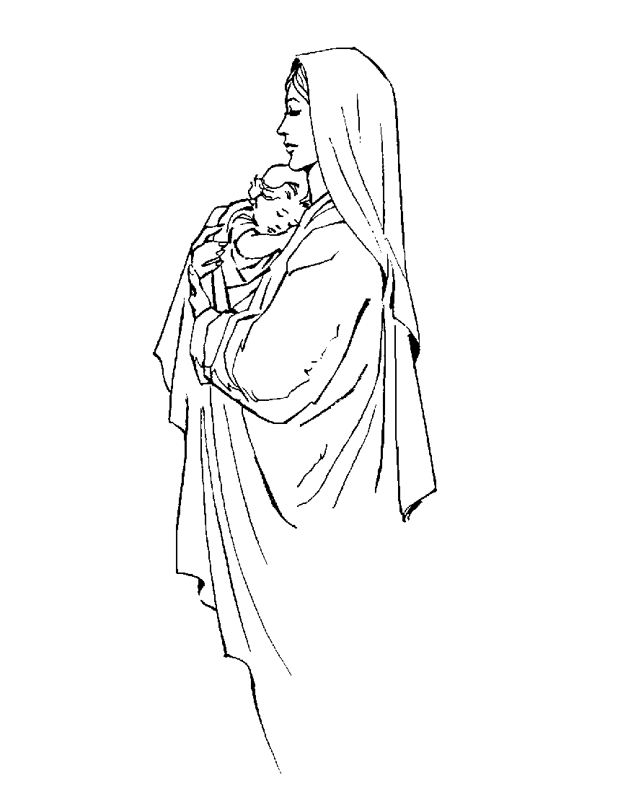
ALL: We love you, Mary.
TEACHER: Mary, you are special because God created you without sin.
ALL: We love you, Mary.
TEACHER: Mary, you are the queen of heaven and earth.
ALL: We love you, Mary.
TEACHER: Mary, help us to live like you did.
ALL: We love you, Mary.
TEACHER: Mary, ask your Son, Jesus, for peace in the world.
ALL: We love you, Mary.

St. Blaise – February 3

God our Father sends us many helpers who lead us closer to Him. Today I am going to tell you the story of a man named Blaise.

Blaise loved God very much. He always tried to please God by spreading His love and happiness. Since Blaise wanted to work for God’s Church, he became a priest. Later he became a bishop. He was a very good man and he loved God’s family. He took care of the people by watching over and guiding them. Some people were jealous of Blaise so they made up lies about him. They wanted to get rid of him. One day a group of men came to take Blaise away. They wanted to kill him because he loved God so much. As they were leading him away, a mother ran up to him holding a little boy. The mother was crying and shouted, “Blaise my child has something caught in his throat. He cannot breathe, but you can make him well again.” Blaise stretched out his hand and blessed the child. Immediately the boy’s throat was cleared and he was well again. Seeing this act, the mean men were upset and they killed Blaise. The people of God knew what great love Blaise had, so the Church made him a saint. That is why we call him St. Blaise.

The Church likes to give us her special blessing on the feast of St. Blaise so we have our throats blessed by the priest. We pray to St. Blaise who will protect us from any sickness of the throat.

Dear God,
Thank You for St. Blaise.
Please watch over anyone who is sick.
Amen.

Lent

Lent is a special time in the Church. It is a time where we learn the great love Jesus has for each one of us. During Lent we stop and think about the life of Jesus. We see His great love for us by His suffering, dying, and rising from the dead. Lent helps us to get ready for Easter. Easter is the time of the new life of Jesus who rose from the dead. During this time we try to become more like Him.

Ash Wednesday is the first day of Lent. On this day we receive a special sign on our foreheads. The priest (or other qualified person) puts ashes on our foreheads as a sign that we are called to be members in God’s family. The ashes come from palm branches. The ashes are placed as a cross on our foreheads, a sign that we love Jesus and that we want to live with Him someday in heaven.

During Lent we should try to do something special as a sign of our love for Jesus.

What can we do for Lent? Let us take time out and think of ways we could practice our love.

To the Teacher: Child draws a face and makes a cross on the forehead with unblessed ashes or black crayon.
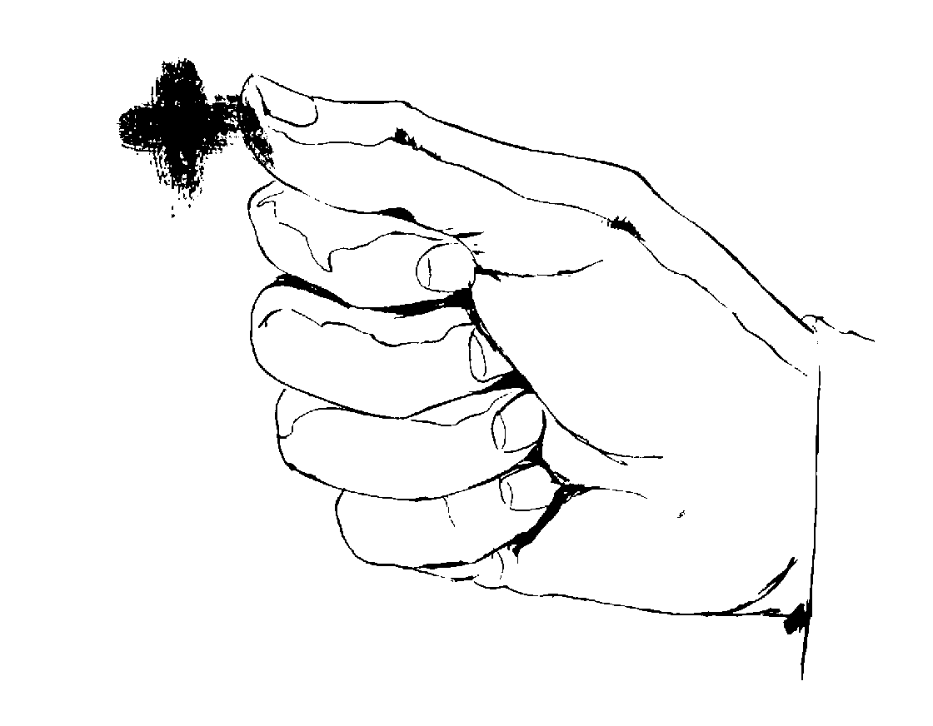

Stations – The Way of the Cross (This type of a lesson would be valuable after studying and discussing the life of Jesus. It can also be used during the Lenten season.)

Jesus came into the world as our brother in order to show us the way to our Heavenly Father. He proved His love for us by doing many hard things. He suffered and died for all of us.

Let us stop and think about the great love of Jesus. In our church, we have special signs or pictures that tell the story of the great love Jesus proved for us.

Take a class tour of the Stations of the Cross in church: As you tour and view each Station, share a few personal views and a prayer.

To the Teacher: Be aware of a child’s sensitivity to pain and suffering. A teacher needs to gauge the appropriateness of the effect of this additional lesson on the students.
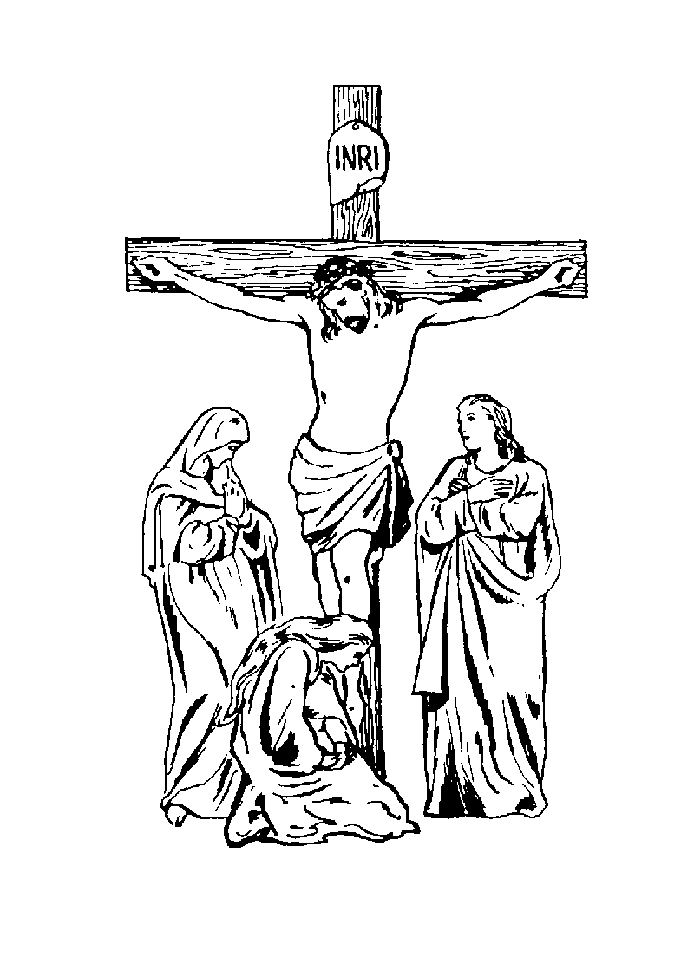

- Jesus is condemned to death.
- Jesus accepts His cross.
- Jesus falls the first time.
- Jesus meets His mother.
- Simon helps Jesus carry His cross.
- Veronica wipes the face of Jesus.
- Jesus falls the second time.

- Jesus speaks to the women and children.
- Jesus falls the third time.
- Jesus is stripped of His garments.
- Jesus is crucified.
- Jesus dies on the cross.
- Jesus is taken down from the cross.
- Jesus is laid in the tomb.


To the Teacher: Pause before the altar when the viewing of the Stations is completed. Tell the children that this story of Jesus doesn’t end until we look up at the altar and come to realize that Jesus suffered, died, and rose from the dead. Explain that Jesus is very present to us today. He is always with us. Let us tell Him quietly within our own hearts how much we love and care about Him.

St. Valentine – February 14

How can we show people that we love them? How do your friends know that you care about them? We celebrate a special day to show people that we love them, and we send them special cards.

What day is it? Valentine’s Day!

Today, I am going to tell you the story of St. Valentine. St. Valentine was a very holy priest who lived a long time ago. He was a very kind and good man. He would like to surprise the poor and sad people by sending them cheery notes telling about God’s goodness to them.

St. Valentine was a very busy person, but he still took time out for people. He showed people what it means to be kind and friendly. Not all people liked the way Valentine would act. They wanted to get rid of him, so they put him into prison. Because of the love Valentine had for God, he was willing to give his life to God. He did this as an act of perfect love.

We can learn a lesson from this great person. We can try to spread more happiness and love to all of God’s people we meet. We can offer up our love by doing good deeds.

Love is the most important thing for everyone. Jesus told His friends over and over again to love one another as He loved them. Jesus taught us how to love.

St. Patrick – March 17

When Patrick was a little boy he was taken away by some pirates. They kidnapped Patrick in order to sell him for money. Some people who didn’t believe in or love God bought Patrick. Patrick lived with these people in Ireland for several years. One day Patrick got away from these people and traveled to Rome.

Patrick loved God and wanted to share his love of God with others so he became a priest and later a bishop. Patrick often thought of the years he lived in Ireland. He thought of the people. So he decided he would lead these Irish people to Jesus.

He traveled to Ireland in order to spread God’s love and happiness. These people were very interested in Patrick’s stories about God and they wanted to enter God’s family by being baptized. Patrick brought many people into God’s family. Because of his love of God, the Church named him St. Patrick.

We can try to be like St. Patrick by spreading God’s happiness to everyone we meet. We can pray to God our Father that by our good example we can lead others to Him.

St. Joseph – March 19

St. Joseph was a very kind man who lived many, many years ago. He always tried to love God and obey Him. St. Joseph was a hard worker. He worked as a carpenter; that is someone who works with wood. Joseph made many things from wood such as tables, chairs, and shelves.

One day Joseph met a lady named Mary. She was the most beautiful lady he had ever seen. Soon Joseph came to know Mary very well and he fell in love with her. He asked Mary to be his wife and she said, “Yes.” Joseph was so happy. He was even happier when an angel came to tell him that Mary would have a very special baby. He would be Jesus. God was asking St. Joseph to take good care of Mary and Baby Jesus.

38
Joseph did his job well, even though it was hard at times. As Jesus grew older, Joseph taught Him to be a carpenter, too. St. Joseph was always a kind and loving husband. Jesus, Mary, and Joseph made a wonderful family. When Joseph died, he had a happy death. He had always done what God wanted him to do. God filled his heart with peace and joy because of his wonderful obedience.

Ascension – Forty Days After Easter

Forty days after Easter, Jesus gathered His apostles around Him on a quiet hillside. There He told them that He would now return to His Heavenly Father because His work was completed here on earth. The apostles were very sad. They didn’t want Jesus to go away. Some of them began to cry and begged Jesus to stay. Some of the apostles shook with fright as they remembered some of the terrible things that had happened to Jesus a few weeks earlier. They were afraid for their own lives, too.

Jesus gently spoke to them and told them not to be afraid. He said it was necessary to return to the Father so that the Holy Spirit could come. He told the apostles to continue their work for God through baptizing and teaching the Good News.

When Jesus finished speaking, the apostles saw Jesus lifted from their sight and taken back to His Father in heaven. As the apostles stood there staring up into the sky, two angels appeared and told them Jesus would come again. Now, they should return to their room to pray and wait for the Holy Spirit to come.

Ascension is what we call the time Jesus ascended (went up) into heaven. His apostles couldn’t see Him anymore. Even though they couldn’t see Him, they knew that Jesus was still with them in a different way now. Jesus is always with us to help us show others how He loves all of us.
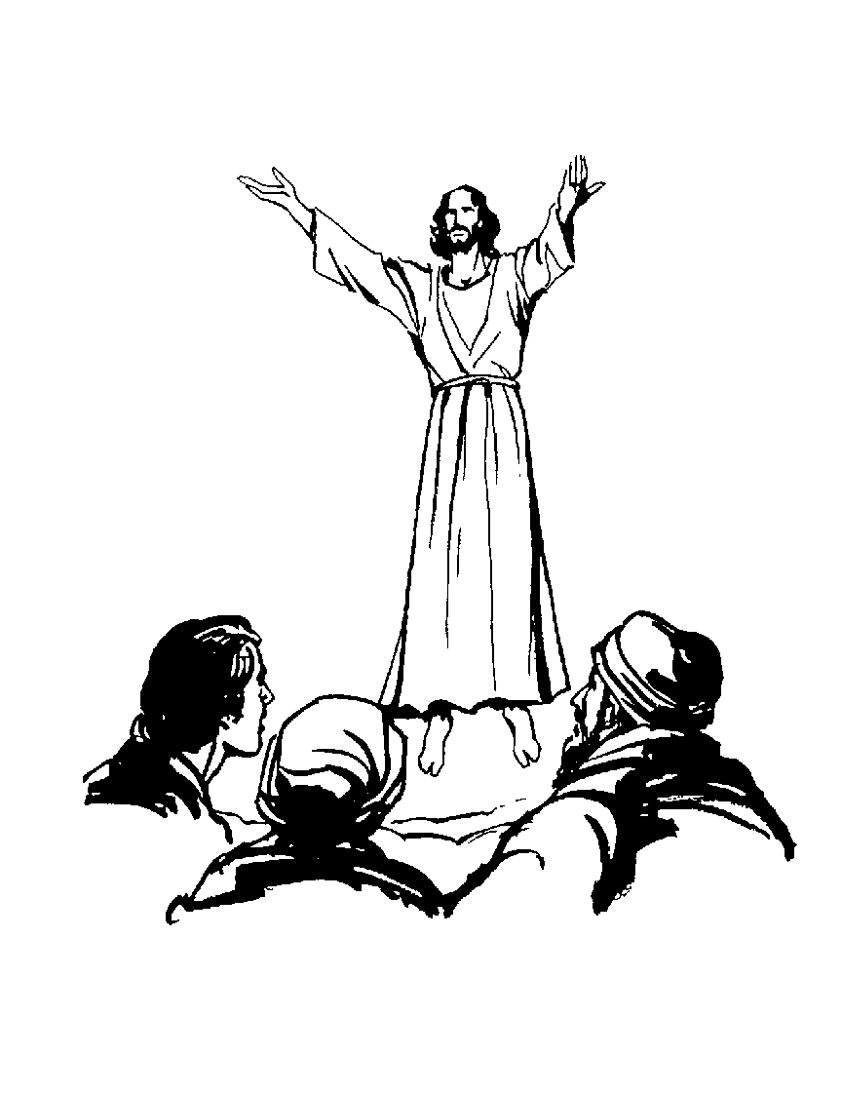

Dear Jesus,
I know that You are near
And though I cannot see you
Your love is always here.
Amen.

May Crowning

God loved Mary so much that when she went to heaven, she was crowned as the Queen of Heaven and Earth. Every May we remember all the wonderful things Mary did during her lifetime. We remember how much she loved Jesus.

During this special time, we tell Mary how much we love her and ask her help in making us good children of God’s family. To honor Mary, we place a crown of flowers on Mary’s head as a sign of our devotion and love for her.

To the Teacher: Prepare a May altar ahead of time with a statue of Mary, candles, and flowers. Have a short service consisting of an opening hymn, short prayer, or a decade of the rosary. This can be followed by the crowning ceremony. Then conclude with a final hymn.
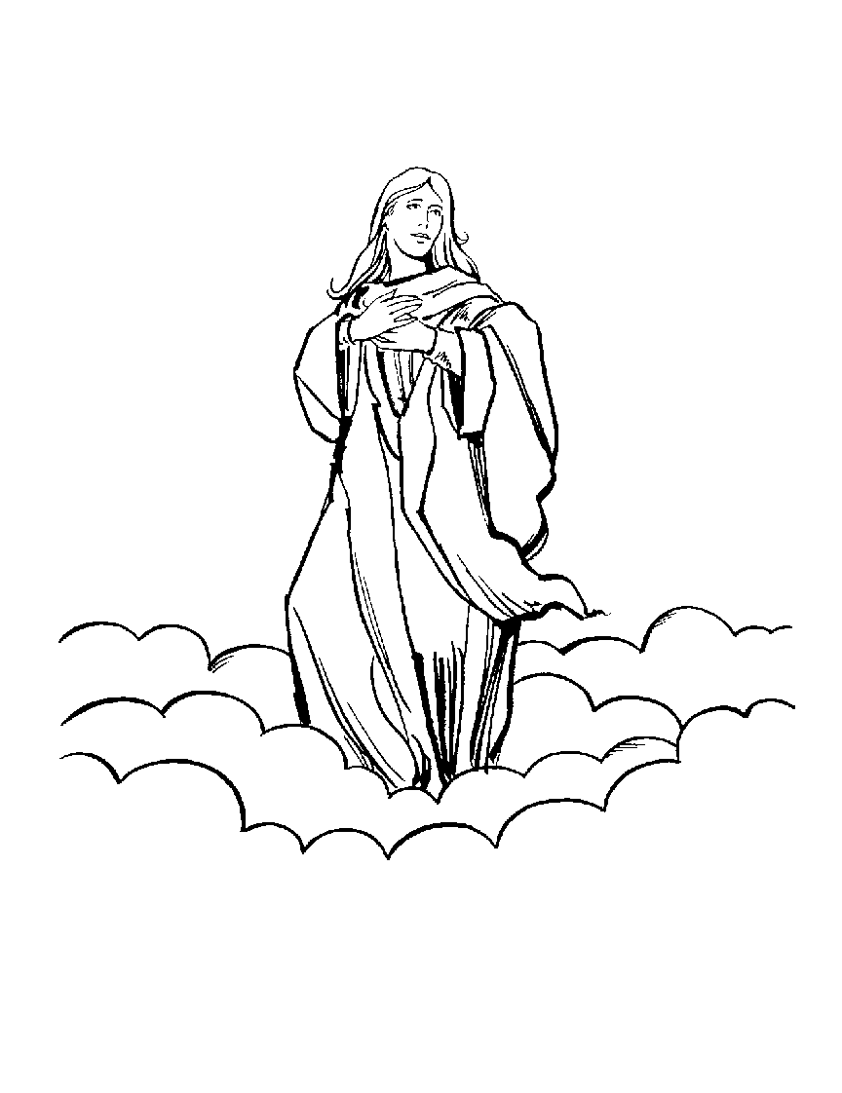
Mary, we crown thee
With blossoms today.
Queen of the angels,
Queen of the May.
The following is a list of video titles which may be useful for the Kindergarten Classroom:

Bible Heroes
Billy Beaver
Boo Boo Monster
Charles Caterpillar
Christmas Gift, A
Christmas Gift for Little Children, A
City That Forgot Christmas, The
Dinty the Leprechaun
Easter Is
Edna Eagle
Folksville Series, The
Forgive and Forget
Francis Xavier and the Samurai’s Lost Treasure
Freckles and Friends
Fuzzy Tale, A
Gerbert
Getting to Know Jesus
Good Tree, A
Grandma’s Ornament
Holy Days and Holidays Series
Joni
Kid Tricks
King Bird’s Big Bash
Little Troll Prince, The
Mary Had a Baby, Amen!
My Father’s House
My Grandson Lew: Memories Don’t Die
Nicholas, The Boy Who Became Santa
On the Way
Ordinary Fir Tree, The
Our Friends on Wooster Square
Patrick, Brave Shepherd of the Emerald Isle
Peer Pressure
Perfect Present, The
Priscilla Tadpole
Proud Tree, The
Pumpkin Who Was Not a Squash, The
Rosary for Little Children, The
Selfish Giant, The
Simon the Lamb
Star for Jeremy, A
Talent for Tony
There’s Nobody Like You
Through Grandpa’s Eyes
Timmy’s Gift
Timmy’s Special Delivery
Valentine Card, The
Value Adventures
Velveteen Rabbit, The
William
Wrongfully Blamed

RESOURCES
- Baker, Carolyn Nabors, The Beginner’s Bible, Dallas, Texas: Word Publishing, 1995

- Cronin, Gaynell Bordes, Holy Days and Holidays: Prayer Celebrations with Children, Revised Edition, Winston Press, Inc. 1985

- Donze, ASC and Mary Therese, Touching a Child’s Heart: Innovative Encouraging Guide to Becoming a Good Story Teller, Notre Dame, IN: Ave Maria Press, 1985

- Every Day with God, A Child’s Daily Bible, Word Publishing, 1990

- Great Beginnings, God’s Promise, The Story of Noah’s Ark, Allen, TX: Thomas More Publishing, 1995

- Happy Day Series, God Made Me Special, Cincinnati, OH: Standard Publishing Co., 1983

- Higgs, Liz Curtis, The Pumpkin Patch Parable, Nashville, TN: Thomas Nelson, Inc., 1997

- The Sunflower Parable, Nashville, TN: Thomas Nelson, Inc., 1997

- Lee, Sharon, Hosanna! Calendars, Creative Projects and Crafts for Lent and Easter, San Francisco, CA: Harper and Row Publishers, 1988

- Leslie, Karen, Faith and Little Children: A Guide for Parents and Teachers, Mystic, CT: Twenty-Third Pub., 1990

- Lovasik, Fr. Lawrence, Prayers to the Boy Jesus, Children’s Prayers to Mary, New York, NY: Catholic Book Pub., Co., 1987
- Plum, Joan Ensor and Music by Jack Miffleton, Prayer Celebrations for Young Children, Huntington, IN: Our Sunday Visitor Pub. Div., Our Sunday Visitor, Inc. 1990

- Plum, Joan Ensor and Paul S. Plum, Teaching Tips for Early Childhood Religious Education, Huntington, IN: Our Sunday Visitor, Inc. 1992

- Porter, Daniel J., My First Book of Prayers, New York, NY: The Regina Press, 1991

- Ratcliff, Donald, Editor, Handbook of Preschool Religious Education, Birmingham, AL; Religious Education Press, 1988

- Savory, Louis M., My Best Friend: A Child’s Life of Jesus, New York, NY: The Regina Press, 1978

- The Saints Volume I and II, New York, NY: The Regina Press, 1989

- Schreiber, Gayle, Prayer Services for Young Children, Mystic, CN: Twenty-Third Pub., 1993

- Tangvald, Christin Harder, A Child’s Book of Prayers, Chariot Books, 1987

- Tangvald, Christin Harder, Three In One, St. Louis, MO: Concordia Pub. House, 1973

- Timeless Children’s Stories, The Beginner’s Bible, Sisters, Oregon: Questar Pub., Inc. 1991

- Weisheit, Eldon, The Gospel for Little Kids: 45 Chapel Talks for Children 3-6, St. Louis, MO: Concordia Pub. House, 1980

- Westerhoff, III, John H., Will Our Children Have Faith?, San Francisco, CA: Harper, 1976

Thematic Children’s Literature

FRIENDSHIP
The Little Prince Antoin de Saint-Exupery
Charlotte’s Web E.B. White
The Velveteen Rabbit Margery Williams

REDEMPTION
Hope for the Flower Trina Paulus
The Banyan Deer from Jataka Tales

RESPONSIBILITY
The Elephant’s Child Rudyard Kipling
Mogo’s Magic Flute Hilda van Stockum

UNSELFISHNESS
The Giving Tree Shel Silverstein
The Selfish Giant Oscar Wilde
The Wolf and the Fox from More Tales of Grimm
The Greedy Brother from Chinese Fairy Tales

FOOLISHNESS
The Fisherman and His Wife Grimm
The Emperor’s New Clothes Hans Christian Andersen

SUFFERING
A Mountaineer’s Tale from Polish Folk Tales
The Willow Leaf Eyebrow from Chinese Fairy Tales
The Real Princess Hans Christian Andersen
Five Peas in a Pod Hans Christian Andersen
The Candles Hans Christian Andersen
Wild Swans Hans Christian Andersen
The Steadfast Tin Soldier Hans Christian Andersen
The Tinder Box Hans Christian Andersen
The Nightingale Hans Christian Andersen
The Fir Tree Hans Christian Andersen

BEAUTY ON THE INSIDE
The Little Singing Frog Yugoslav Folk and Fairy Tales – Harcourt Brace
(from the Laughing Prince) collected and retold by Parker Fillmore;
The Ugly Duckling Hans Christian Andersen
Crow Boy Taro Yashina
One Hundred Dresses Eleanor Estes
Anansi’s Hat Shaking Dance (from the Hat-Shaking Dance from the Gold Coast) Compiled by Harold Courlander with Albert Kofi Prempeh
The Happy Prince Oscar Wilde

COOPERATION
The Loudest Noise in the World Benjamin Elkin
The Emir’s Son Martin Ballard
The Bundle of Sticks from Aesop’s Fables
The Four Oxen and the Lion from Aesop’s Fables

HAPPINESS
The Laughing Prince from Yugoslav Folk and Fairy Tales
The King and the Shirt from Fables & Fairy Tales
retold by Leo Tolstoy
The Happy Cure retold by Rose Dobbs

USING ONE’S GIFTS
The Mouse, the Bird and the Sausage from More Tales from Grimm
Jupiter and the Horse from Just One More Jeanne B. Hardendorff
Hafix, the Stone-cutter adapted and arranged by
Marie Shedlock

OBEDIENCE
The Tale of Peter Rabbit Beatrix Potter
The Tale of Jemima Puddleduck Beatrix Potter
Jonah and the Lord George Macbeth

COURAGE
Rikki-Tikki-Tavi from The Jungle Book, Rudyard Kipling
The Steadfast Tin Soldier Hans Christian Andersen
The Bell Ringer of Pinsk Eric P. Kelly
The Lion’s Share from Aesop’s Fables

TRUTH
Many Moons James Thurber
The Boy Who Could Sing Pictures Seymore Leichman
The Nightingale Hans Christian Andersen
The Golden Seed Maria Konopnicka
Rumpelstiltskin from The Brothers’ Grimm
The Shepherd Boy and the Wolf from Aesop’s Fables
The Pied Piper of Hamlin Robert Browning

GRATITUDE
Androcles and the Lion from Aesop’s Fables
The Lion and the Mouse from Aesop’s Fables
The Dove and the Ant from Aesop’s Fables
The Tailor of Gloucester Beatrix Potter

RESOURCES

- Blackburn, Barbara, The Life Project, Liguori, MO: Liguori Pub., 1995
(Forming Christian attitudes toward death and dying)

- Daniel, Rebecca, Biblical Christmas Performances, Carthage, IL: Shining Star Pub., 1988

- MacClennan, Carole, Learning by Doing, 150 Activities to Enrich Religion Classes for Young Children, Mystic, CN: Twenty-Third Pub., 1993

- Schraff, Francis, Anne Schraff, and Sister Suzanne Hockel, Learning About Jesus: Stories, Plays, Activities for Children, Liguori, MO: Liguori Pub., 1980

- Standke, Linda, New Testament Bible Story Crafts, Grand Rapids, MI: In Celebration, 1996

- Stohs, Anita Reith, Christian Crafts for Holidays, Carthage, IL: Shining Star Pub., 1994

- Yawger, Kathleen Sander, Bible Story Crafts, Carthage, IL: Shining Star Pub., 1991

BOOKS FOR CHILDREN

Colina, Teresa and Jean Shannon, Tom’s Terrible Secret, Cincinnati, OH: Standard Pub. Co., 1981
DeLuise, Dom, Charles the Caterpillar, New York, NY: Simon and Schuster, Inc., 1990
Doleski, Teddi, The Hurt, Mahwah, NJ: Paulist Press, 1983
Gayle, Sharon Savers, A Kwanzaa Miracle, Mahwah, NJ: Whistle Stop, 1966
Hutson, John, I Think . . .I Know . . ., Notre Dame, IN: Ave Marie Press, 1979
Lessor, Richard, Fuzzies, Niles, IL: Argus Communication, 1975
McKee, David, Elmer, New York, NY: Lothrop, Lee & Shepard Books, 1968
Pfister, Marcus, The Rainbow Fish, New York, NY: North-South Books. 1992
Raffi, One Light, One Sun, New York, NY: Crown Pub. Inc., 1988
Rose, Gerald, Trouble In The Ark, Harrisburg, PA: Morehouse Pub., 1989
Ross, Tom, Eggbert – the Slightly Cracked Egg, New York, NY: G.P. Putnam’s Sons, 1994
Shortsleeve, Kevin, God Knows, Boston, MA: St. Paul Books and Media, 1995
Silverstein, Shel, The Giving Tree, New York, NY: Harper & Row Publisher, 1964
Sosé, Bonnie, Designed By God So I Must Be Special, Winter Park, FL: Character Builders for Kids, 1988
Vaughan, Marica, Hands, Hands, Hands, Greenvale, NY: Mondo Pub., 1995

