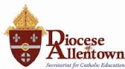 KINDERGARTEN PROGRESS REPORT
2nd and 3rd TRIMESTER

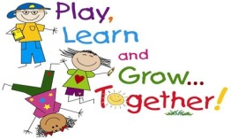

SKILLS FOR SUCCESSFUL LEARNERS
- Code: + Consistently observed √ Developing skill

Religion:

- __Makes and says Sign of the Cross appropriately

- __Participates appropriately during prayers, class, and Mass

Christian Values:

- __ Shows respect for authority, self and others

Language Arts:

- __ Works on grade level

Mathematics:

- __ Works on grade level

Student Name: ____________________________________

Parent Signature: __________________________________ Date: ___________

Please sign and return. Thank you.

