KINDERGARTEN PROGRESS REPORT 1ST TRIMESTER

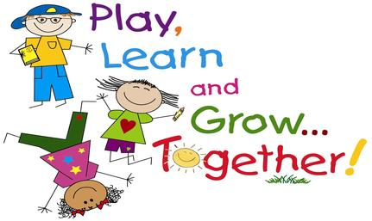

SKILLS FOR SUCCESSFUL LEARNERS
- Code: + Consistently observed √ Developing skill

Social Development:
- __ Demonstrates self-control
- __ Respects authority
- __ Follows classroom/school rules
- __ Demonstrates good manners
- __ Raises hand, waits for turn to speak
- __ Works and plays cooperatively
- __ Uses appropriate verbal skills to solve problems

Work Habits:
- __ Demonstrates appropriate attention span
- __ Works independently
- __ Sits and works quietly without disturbing others
- __ Completes tasks on time
- __ Seeks help when needed
- __ Takes care of materials/personal needs
- __ Completes tasks neatly

Readiness Skills:
- __ Recognizes most upper and lower case letters
- __ Recognizes most letter sounds
- __ Instant recall of most learned sight words
- __ Recognizes numbers 0-10

Student Name ____________________________________

Parent Signature __________________________________ Date:___________

Please return before or during conference time. Thank you.

