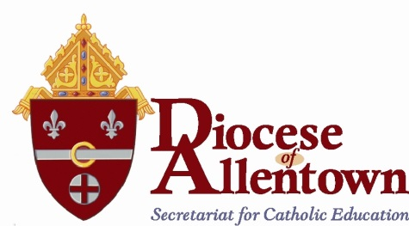

TO: Principals, Science Coordinators and Science Teachers
FROM: Sister Anita Patrick Gallagher, I.H.M. Assistant Superintendent for Elementary Education
RE: Final Science Overview and Scope and Sequence
Dear Colleagues,
The Science Curriculum Committee for the Diocese of Allentown presents the revised and final copy of the Science Standards for Grades K-8. This culmination of efforts began with discussions about the intentions for a framework that would address the need for a spiraling curriculum that incorporated all key sciences yet one that prevented redundancy and allowed for depth of topic rather than merely breadth. The national, state, and local call to include more technology or design-based instruction lies at the core of this new framework. Among those documents referenced and incorporated were the National Science Educational Standards, the Next Generation Science Standards, the Core Curriculum for Reading and Writing in Science, and the Academic Standards for Science and Technology and Engineering Education by the state of Pennsylvania. Other state science standards, including those of New Jersey, New York, Massachusetts, Ohio, California, and Vermont were also considered. Locally and within our Diocese, elementary and high school surveys were conducted and helped to inform the following drafts.
The following documents include an Overview of concepts for each grade level, as Enduring Knowledge blocks for each trimester (Unit 1, 2, 3). Each block of the Overview represents a one to two week period as per each teacher’s discretion and schedule. An accompanying document entitled Scope and Sequence defines each of the Enduring Knowledge concepts as concrete objectives, vocabulary, and suggested activities. Additional activities, such as websites, Apps, and virtual labs, are listed by science discipline in an Annex which will be reviewed and updated yearly by the suggestions of Diocesan science teachers.
Hands-on laboratory activities, in addition to teacher demonstrations, are expected to accompany each Enduring Knowledge block. Evaluations of student understanding of these activities, such as laboratory reports, should be included as assessments for students of grades 5-8. These documents will help guide, prepare teacher and student, for success on upcoming trimester assessments.
Diocese of Allentown Science Curriculum Committee

